**ASSIGNMENT 4**

1. Write a program to print MySirG 5 times on the screen

**Ans.** //Write a program to print MySirG 5 times on the screen

#include<stdio.h>

#include<conio.h>

int main()

{

int i;

while(i<=4)

{

printf("MySirG ");

i++;

}

getch();

}



1. Write a program to print the first 10 natural numbers.

**Ans**. //program to print the first 10 natural numbers.

#include<stdio.h>

#include<conio.h>

main()

{

int i=1;

printf("first 10 natural number is:\n");

while(i<=10)

{

printf("%d\n",i);

i++;

}

getch();

}

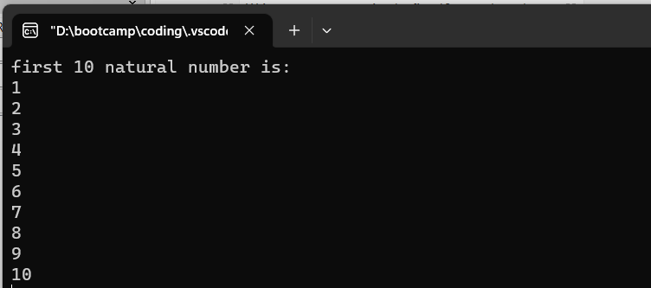

1. Write a program to print the first 10 natural numbers in reverse order

**Ans.** //program to print the first 10 natural numbers in reverse order

#include<stdio.h>

#include<conio.h>

main()

{

int i=10;

printf("first 10 natural number in reverse order is:\n");

while(i>=1)

{

printf("%d\n",i);

i--;

}

getch();

}

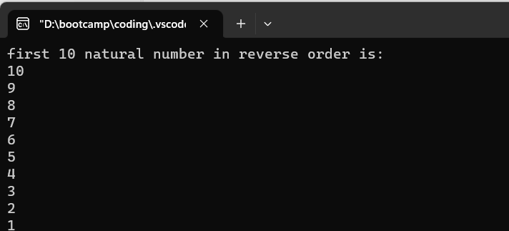

1. WAP to print the first 10 odd natural numbers

**Ans.** //Write a program to print the first 10 odd natural numbers

#include<stdio.h>

#include<conio.h>

main()

{

int i=1, a=0;

printf("The first 10 odd natural numbers are:\n");

while (a<10)

{

if(i%2!=0)

{

printf("%d\n",i);

a++;

}

i++;

}

getch();

}

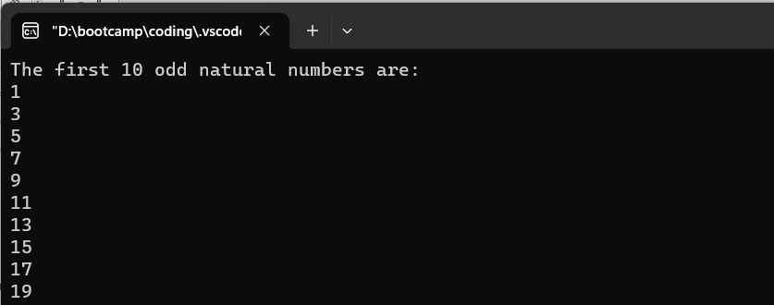

1. WAP to print the first 10 odd natural numbers in reverse order.

**Ans.** //program to print the first 10 odd natural numbers in reverse order.

#include<stdio.h>

#include<conio.h>

main()

{

int i=19, a=10,r;

printf("The first 10 odd natural number in reverse order is:\n");

while (a>0)

{

r=i%2;

if(r!=0) {

printf("%d\n",i);

a--;

}

i--;

}

getch();

}

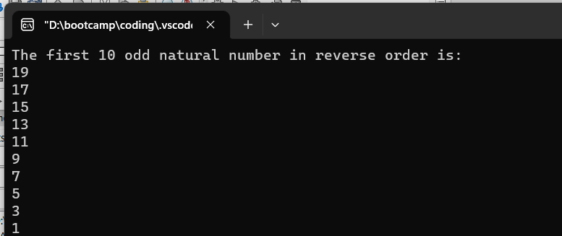

1. WAP to print the first 10 even natural numbers

**Ans.**  //program to print the first 10 even natural numbers

#include<stdio.h>

#include<conio.h>

main()

{

int i=2, a=1,r;

printf("first 10 even natural number are: ");

while(a<11)

{

r=i%2;

if(r==0)

{

printf("%d\n",i);

a++;

}

i++;

}

getch();

}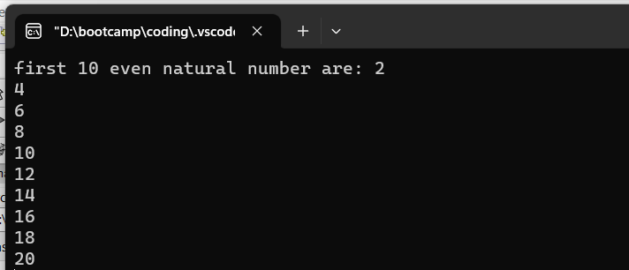

1. Write a program to print the first 10 even natural numbers in reverse order

**Ans.** //program to print the first 10 even natural numbers in reverse order

#include<stdio.h>

#include<conio.h>

main()

{

int i=20,a=10,r;

printf("first 10 even natural numbers in reverse order are:");

while(a>0)

{

r=i%2;

if(r==0)

{

printf("%d\n",i);

a--;

}

i--;

}

getch();

}

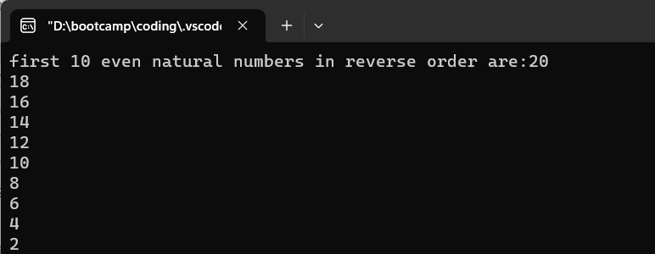

1. Write a program to print squares of the first 10 natural numbers

**Ans.**  //program to print squares of the first 10 natural numbers

#include<stdio.h>

#include<conio.h>

main()

{

int i=1;

while(i<=10)

{

printf("square of %d is %d\n",i,i*i);

i++;

}

getch();

}

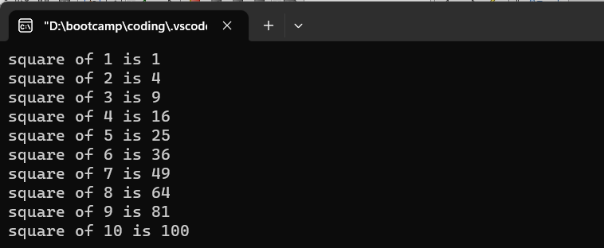

1. WAP to print cubes of the first 10 natural numbers

Ans. //program to print cubes of the first 10 natural numbers

#include<stdio.h>

#include<conio.h>

main()

{

int i=1;

while(i<=10)

{

printf("cube of %d is %d\n",i,i*i*i);

i++;

}

getch();

}

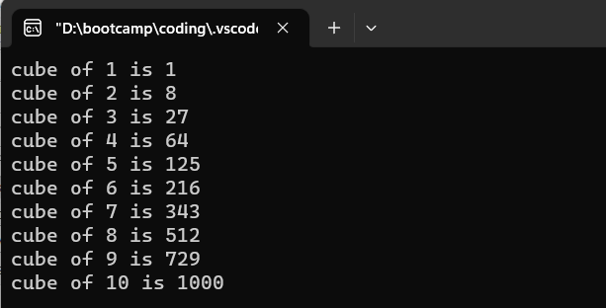

1. WAP to program to print a table of 5.

**Ans.** //program to print a table of 5

#include<stdio.h>

#include<conio.h>

main()

{

int i=5,a=1;

while(a<=10)

{

printf("%d*%d = %d\n",i,a,i*a);

a++;

}

getch();

}

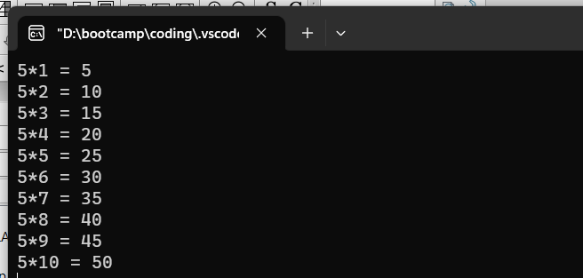

Thank You!!